Cass High School Cheerleading
YETI Raffle: Roadie 20
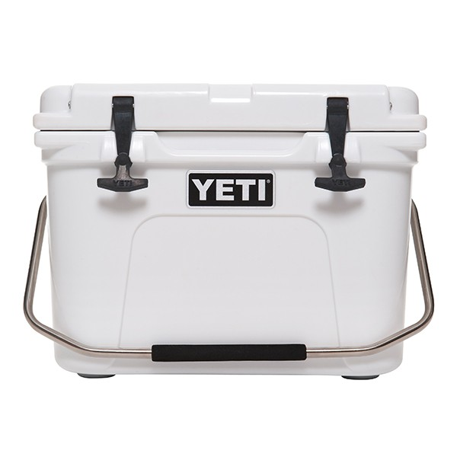
Description: The Yeti Roadie 20 is a personal sized cooler that weighs 15lbs. and stands 13 ¾ inches x 19 inches.

Each cheerleader is being asked to sell a minimum of 12 raffle tickets. Each ticket is $5.00 and ALL of the money raised will go toward each individual girl’s account. This fundraiser will begin March 24th and the deadline to turn in all tickets and money is Thursday April 14th.

