The Game Day Shirt Fundraiser

I have completed my fundraiser now what?

Step 1: Go to the link below to enter you shirt information.

https://docs.google.com/forms/d/1Vo_c0122ItKf4BIAQXwcLr70tp25qE1LFeuU16eWve0/viewform
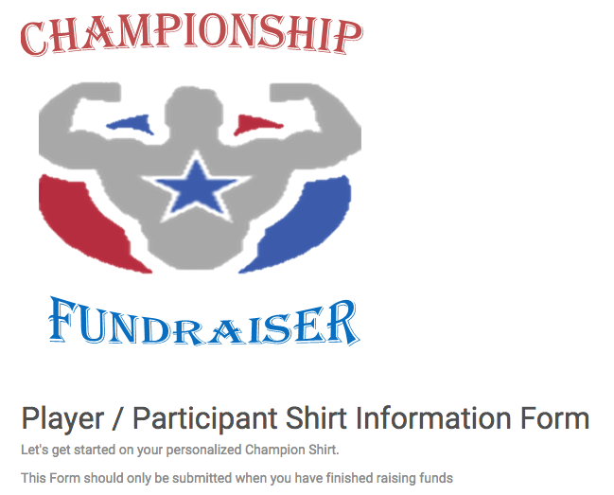

Step 2: Fill out Team Name (Cass High School Cheerleading), First and Last Name, and select your shirt size.

Step 3: One by one enter each message into the space provided. Remember, you can only enter 32 characters including spaces. Please be sure to double-check all personal messages before submitting. Champion Fundraiser is not responsible for any typing, spelling, or grammatical errors.

Step 4: Scroll all the way to the bottom of the page and click submit.

